Appointment as Visiting Professor (any rank; please see below for Visiting Scholar appointments)

- Letter from the department chair explaining the proposed appointment with faculty vote. Appointments will be at the corresponding rank that the candidate holds at his/her current institution.
- Letter to the chair from the faculty member explaining the research that the visiting professor will be conducting and the relevance to the faculty member’s research program.
- Updated Curriculum vitae WITH DATE
- Space must be available within the faculty member’s lab or office for the visitor.
- Appointments are for one year, with possibility of reappointment for one additional year.
- Appointment should be at no cost to the School/University. Candidate must provide statement as to source of funding and that health insurance is in place.
- Visa requirements are handled through Kathryn Fogle, the Immigration and Employment Compliance Manager and the BA in association with ISSS. Please copy her on all requests for appointments of foreign nationals as Visiting Faculty. Bringing her in the loop early on will help with the visa application process.

Appointment as Visiting Scholar

- Letter from the Chair explaining the proposed appointment with faculty vote. A Visiting Scholar position is used for visitors who do not hold the rank of Assistant, Associate or Full Professor at another institution but who have the requisite credentials (e.g., a postdoc visiting from another institution, recent graduate, research scientist).

- Updated Curriculum vitae WITH DATE

- Internal letter from faculty member with whom candidate will work.

- Space must be available within the faculty member’s lab or office for the visitor.

- Appointments are for one year, with possibility of reappointment for one additional year. Note that Visiting Scholar positions are internal School appointments and do not go through Provost Staff Conference Subcommittee.

- Appointment should be at no cost to the School/University. Candidate must provide statement as to source of funding and that health insurance is in place.

- Visa requirements are handled through Kathryn Fogle, the Immigration and Employment Compliance Manager and the BA in association with ISSS. Please copy her on all requests for appointments of foreign nationals. Bringing her in the loop early on will help with the visa application process.

Classification Checklist

Please use the table below in helping to determine whether a visitor to Penn is correctly categorized as a Visiting Scholar. Alternate suggestions for classification are offered in the right-hand column.
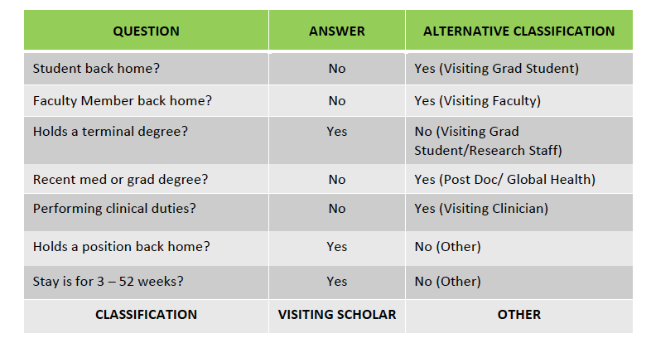

Duration of visit

Visitors who will be at Penn for longer than one year are not eligible for an appointment as a “Visiting Scholar.” If you anticipate that the visitor will be at Penn for longer than a year, it would be best to consider an alternate classification (faculty, grad student, post doc, or employee).

Appropriate immigration mechanism: Based on the qualifications and role of the visitor (see above), please consult OIP-ISSS to determine the appropriate visa for foreign visitors to Penn. This should be done prior to the initial appointment and will assure that the visitor has the appropriate travel authorization from his/her home country prior to entering the United States. http://www.upenn.edu/oip/isss/

